INTRODUCTION

1.Project Overview

The objective of this project is to build a Vehicle Parking management system that enables the time management and control of vehicles using number plate recognition.The system that will track the entry and exit of cars, maintain a listing of cars within the parking lot, and determine if the parking lot is full or not.

2.purpose

1. Streamlining Operations A vehicle management system (VMS) streamlines fleet operations by integrating technologies like GPS tracking, IoT, and more that help in providing real-time data for monitoring. ...

2. Improved Decision Making As fleet managers, you might already know the importance of data. ...

3. Cost Efficiency ...

|  |  |
| --- | --- |
| Date | 31 January 2025 |
| Team ID | LTVIP2025TMID19432 |
| Project Name | Vechicle management system using salesforce |
| Maximum Marks | 4 Marks |

Project Design Phase-II

Data Flow Diagrams:

Data Flow Diagram (DFD) provides a visual representation of the flow of information (i.e. data) within a system. By drawing a Data Flow Diagram, you can tell the information supplied by and delivered to someone who take part in system processes, the information needed in order to complete the processes and the information needed to be stored and accessed.

Example:(simplified)

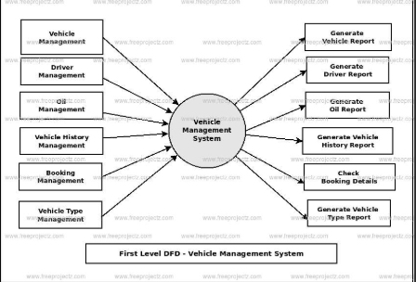

FLOW

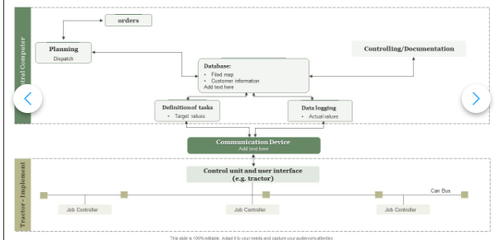

• VIN (Vehicle Identification Number)

• Make, Model, Year

• Color, Mileage

• Registration Number

• Purchase Date, Price

• Warranty Information

User Stories

Use the below template to list all the user stories for the product.

|  |  |  |  |  |  |  |
| --- | --- | --- | --- | --- | --- | --- |
| **User Type** | **Functional Requirement (Epic)** | **User Story Number** | **User Story / Task** | **Acceptance criteria** | **Priority** | **Release** |
| Customer (Mobile user) | Registration | USN-1 | As a user, I can register for the application by entering my email, password, and confirming my password. | I can access my account / dashboard | High | Sprint-1 |
| Customer (Mobile user) | Registration | USN-2 | As a user, I will receive confirmation email once I have registered for the application | I can receive confirmation email & click confirm | High | Sprint-1 |
| Customer (Mobile user) | Registration | USN-3 | As a user, I can register for the application through Facebook | I can register & access the dashboard with Facebook Login | Low | Sprint-2 |
| Customer (Mobile user) | Registration | USN-4 | As a user, I can register for the application through Gmail | I can register & access the dashboard with gmail Login | Medium | Sprint-1 |
| Customer (Mobile user) | Login | USN-5 | As a user, I can log into the application by entering email & password | I can register & access the dashboard with login | High | Sprint-1 |

**Solution Requirements (Functional & Non-functional)**

|  |  |
| --- | --- |
| Date | 31 January 2025 |
| Team Id | LTVIP2025TMID19432 |
| Project name | Vehicle management system using Salesforce |
| Maximum marks | 4 |

**Functional Requirements:**

Following are the functional requirements of the proposed solution.

|  |  |  |
| --- | --- | --- |
| **FR No.** | **Functional Requirement (Epic)** | **Sub Requirement (Story / Sub-Task)** |
| FR-1 | User Registration | Registration through Form  Registration through Gmail  Registration through LinkedIN |
| FR-2 | User Confirmation | Confirmation via Email  Confirmation via OTP |

**Non-functional Requirements:**

Following are the non-functional requirements of the proposed solution.

|  |  |  |
| --- | --- | --- |
| **FR No.** | **Non-Functional Requirement** | **Description** |
| NFR-1 | **Usability** | It is the ease at which the users operate the system and make productive use of it. |
| NFR-2 | **Security** | In-vehicle systems, like infotainment, navigation, and driver quality attributes like performance, security, reliability, usability. |
| NFR-3 | **Reliability** | Reliability – this type of non functional requirement is concerned with characteristics such as availability of the solution. |
| NFR-4 | **Performance** | the context of vehicles, non-functional requirements regarding performance encompass how well the vehicle performs, such as speed, acceleration, handling, fuel efficiency, and safety features, all aspects that go beyond the basic function of driving. |
| NFR-5 | **Availability** | Non-functional availability requirements define how consistently and predictably a system should be accessible and operational. |
| NFR-6 | **Scalability** | the context of vehicles and their systems, non-functional requirements (NFRs) regarding scalability focus on how the vehicle or its components can handle increased demands . |

**Project Design Phase-II**

**Technology Stack (Architecture & Stack)**

|  |  |
| --- | --- |
| Date | 31 January 2025 |
| Team Id | LTVIP2025TMID19432 |
| Project Name | Vehicle management system using salesforce |
| Maximum marks | 4 |

**Technical Architecture:**

The Deliverable shall include the architectural diagram as below and the information as per the table1 & table 2

**Example: Order processing during pandemics for offline mode**

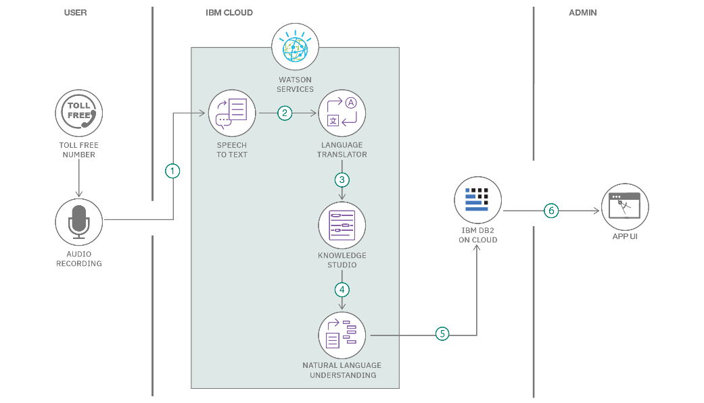

**Table-1 : Components & Technologies:**

|  |  |  |  |
| --- | --- | --- | --- |
| **S.No** | **Component** | **Description** | **Technology** |
|  | User Interface | How user interacts with application e.g.  Web UI, Mobile App, Chatbot etc. | HTML, CSS, JavaScript / Angular Js / React Js etc. |
|  | Application Logic-1 | Logic for a process in the application | Java / Python |
|  | Application Logic-2 | Logic for a process in the application | IBM Watson STT service |
|  | Application Logic-3 | Logic for a process in the application | IBM Watson Assistant |
|  | Database | Data Type, Configurations etc. | MySQL, NoSQL, etc. |
|  | Cloud Database | Database Service on Cloud | IBM DB2, IBM Cloudant etc. |
|  | File Storage | File storage requirements | IBM Block Storage or Other Storage Service or Local Filesystem |
|  | External API-1 | Purpose of External API used in the application | IBM Weather API, etc. |
|  | External API-2 | Purpose of External API used in the application | Aadhar API, etc. |
|  | Machine Learning Model | Purpose of Machine Learning Model | Object Recognition Model, etc. |
|  | Infrastructure (Server / Cloud) | Application Deployment on Local System / Cloud  Local Server Configuration:  Cloud Server Configuration : | Local, Cloud Foundry, Kubernetes, etc. |

**Table-2: Application Characteristics:**

| **S.No** | **Characteristics** | **Description** | **Technology** |
| --- | --- | --- | --- |
|  | Open-Source Frameworks | List the open-source frameworks used | Technology of Opensource framework |
|  | Security Implementations | List all the security / access controls implemented, use of firewalls etc. | e.g. SHA-256, Encryptions, IAM Controls, OWASP etc. |
|  | Scalable Architecture | Justify the scalability of architecture (3 – tier, Micro-services) | Technology used |
|  | Availability | Justify the availability of application (e.g. use of load balancers, distributed servers etc.) | Technology used |
|  | Performance | Design consideration for the performance of the application (number of requests per sec, use of Cache, use of CDN’s) etc. | Technology used |

Conclusion:

In conclusion, a successful requirement analysis for a vehicle management system (VMS) identifies user needs and business requirements to create a robust system for efficient fleet management and operation, driving efficiency, safety, and compliance

THANKYOU TEAM SMARTBRIDGE

BORRA HEMALATHA(Teamleader)